“A GOOD READ” – Berkshire’s only book award chosen by young people for young people
The Award
The Berkshire Book Award was launched in 2004 and has been tremendously successful and popular with young people aged 11-14 who live or go to school in Berkshire. This year we received 170 nominations for over 80 books. The Award is unique in the county and differs from other Award schemes through its involvement of young readers in both nominating the titles and selecting the winner. Previous winners have included Jeff Kinney, Robert Muchamore and J.K. Rowling.
The 2018 Award was launched in October by author Ali Sparkes, with events at Langley Grammar and Reading School. Young people all over Berkshire then nominated their favourite new books of the last year and a shortlist was announced on Wednesday 7th February at the Pen2Page events held at Easthampstead Park Community School, Bracknell and Oakbank School, Reading, featuring author Joffre White.

And the Winner is…
Never Say Die by Anthony Horowitz
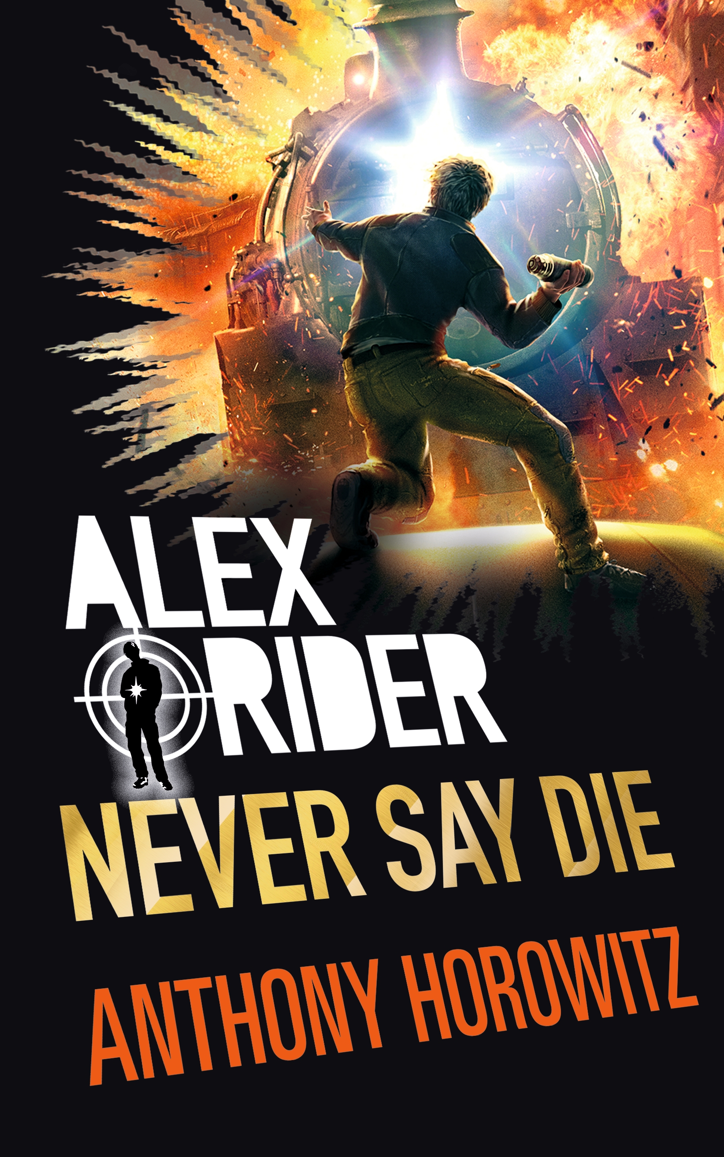
The eleventh instalment of the ever-popular Alex Rider series has wowed readers across the county…
In this brand new, explosive adventure in the number one bestselling series, Alex Rider is trying to get his life back on track after the traumatic events of his last mission. But even Alex can’t fight the past … especially when it holds a deadly secret.
In all, votes were counted from over 300 young people from across Berkshire, with the winning title securing over 23% of the vote. It was a close race, however with second placed Murder in Midwinter by Fleur Hitchcock getting 20% of the vote and in The Dark Prophecy by Rick Riordan coming third with 17% of the vote
Once again we have been supported by Waterstones Bookshops who have promoted the Berkshire Book Award in their stores across the county. We are also grateful for the support given by colleagues in the Public Library Service across the whole of the county, with promotional book displays, book groups and encouraging voting by young people in our public libraries.
Huge thanks go to our sponsors LVS Ascot, Pickabook and Reddam House.
All the 2018 short listed authors will be invited to our 2018 Launch which will take place just before October half term.
For more information: www.berkshirebookaward.org.uk

Contact: Emma Keeler (Chair) tel: 01344 882770 email: emma.keeler@lvs.ascot.sch.uk

