Berkshire Book Award 2020
Schools Voting Form
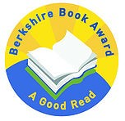

School Name: | Date:
Book Title | Number of votes
Secret Weapon (short story collection)
Horowitz, Anthony
Diary of a Wimpy Kid: The Meltdown
Kinney, Jeff
Five Feet Apart
Lippincott, Rachel
The Day I was Erased
Thompson, Lisa
The Dog Who Saved the World
Welford, Ross
Snowglobe
Wilson, Amy

Please email completed forms to: berkshirebookaward@gmail.com by 4pm on Friday 20th March.

